2.75: a) The particle's velocity and position as functions of time are

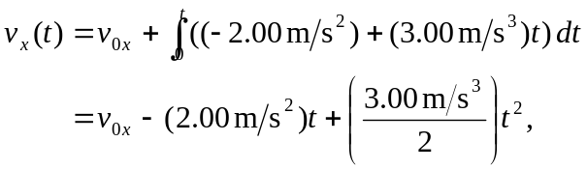

where x₀ has been set to 0. Then, x(0) = 0, and to have x(4 s) = 0,

which is solved for 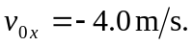 b) 